**Technical Documentation – PENC MiddleWare – ElasticSearch Service Control**

1. Workflow – Stops, Starts, Restarts the Elastic Search Service for All Liferay Environments.

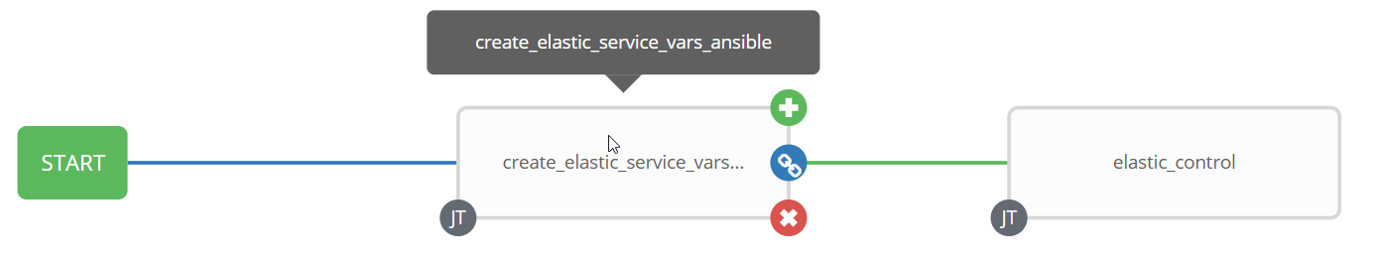

1. Survey – User Supplied Variables

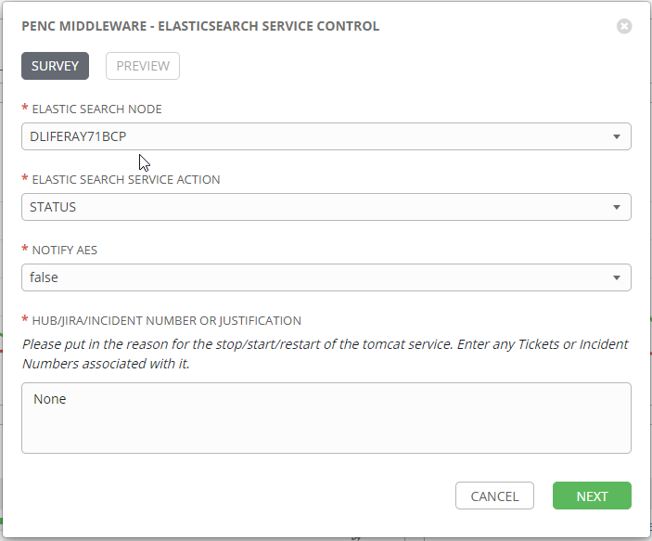

| **Survey Extra Variables** | **Prompt** | **Type** | **Description and Usage** |
| --- | --- | --- | --- |
| elastic_env | Elastic Search Node | Multiple Choice Single Pick | This is a drop down list of the current Elastic Search Nodes  DLIFERAY71BCP,DLIFERAY72BCP  DLIFERAY71BCP  DLIFERAY72BCP  TLIFERAY71BCP,TLIFERAY72BCP  TLIFERAY71BCP  TLIFERAY72BCP  MLIFERAY71BCP,MLIFERAY72BCP  MLIFERAY71BCP  MLIFERAY72BCP  PLIFERAY71BCP,PLIFERAY72BCP  PLIFERAY71BCP  PLIFERAY72BCP |
| elastic_command | Elastic Search Service Action | Multiple Choice Single Pick | The available commands for the Elastic Search Node  Drop Down List:  RESTART  START  STATUS  STOP |
| notify_aes | Notif AES Of The Action | Multiple Choice Single Pick | If set to true send an email to the email addresses defined in {{aes_mail_list}}. |
| aes_note | HUB/JIRA/INCIDENT Number or Justification | Text Area (20000 characters) | Any information entered here will be included in the emails generated. |

Jobs Used by the workflow - http://owl.penc.local:18080/svn/deploy_automation/trunk/Ansible_PlayBooks/Utilities

| **Job Template** | **Ansible Playbook** | **Credentials / host** | **Project** | **Description and Usage** |
| --- | --- | --- | --- | --- |
| create_elastic_service_vars_ansible | create_elastic_service_vars_ansible.yml | None – runs on localhost as awx linux user | Utilities | Creates Variables/Artifacts for use within the workflows, based on the User supplied survey results.  Artifacts Defined with examples  ENV: DEV  date_time: '20210907_0820'  elastic_home: /pencmw/elasticsearch  elastic_host: dliferay72bcp  elastic_lang: en_US  elastic_path: >-  /usr/local/bin:/bin:/usr/bin:/usr/local/sbin:/usr/sbin:/home/pencmw/.local/bin:/home/pencmw/bin:/pencmw/java/jdk/bin  elastic_port1: 9200  elastic_port2: 9300  elastic_tmpdir: /pencmw/elasticsearch/ES_TEMP  tower_host: pdeploy1bcp.penc.local |
| elastic_control | elastic_control.yml | pencmw for {{elastic_host}} | Utilities | On {{elastic_host}}:  With {{elastic_command}} == ‘STOP’ or ‘RESTART’  Puts the elastic search PID into {{elastic_pid_actual.stdout}}.  Executes ‘sudo systemctl stop elasticsearch’.  Waits for /proc/{{elastic_pid_actual.stdout}}/status to be gone.  With {{elastic_command}} == ‘START’ or ‘RESTART’  Executes ‘sudo systemctl start elasticsearch’.  With {{elastic_command}} == ‘STATUS’ or ‘STOP’ or ‘START’ or ‘RESTART’  Checks for ports 9200 and 9300 to see if they are listening.  Updates port_9200_status and port_9300_status with their status’s.  Executes ‘sudo systemctl status elasticsearch’.  Emails the status of elastic search to the tower_user who initiated the workflow. |

1. Workflow Extra Vars – Defined at the Workflow Level

|  |  |  |
| --- | --- | --- |
| **Extra Variable** | **Example Values** | **Description and Usage** |
| aes_mail_list | aes_mail_list:  Mike.Charchuk@dxcas.com | If this variable is defined to anything other than ‘’ and {{notify_aes}} == true an email with the actions taken to addresses defined in {{aes_mail_list}}.  Note: the following are valid aes_mail_list entries:  aes_mail_list: ‘’  aes_mail_list:  [Mike.Charchuk@pensionsbc.ca](mailto:Mike.Charchuk@pensionsbc.ca)  [Mike.Charchuk@dxcas.com](mailto:Mike.Charchuk@dxcas.com)  aes_mail_list:  [Mike.Charchuk@pensionsbc.ca](mailto:Mike.Charchuk@pensionsbc.ca) |